**AN EXPLORATORY STUDY OF NORTHERN LONG-EARED BATS ON NANTUCKET**

Zara Dowling, Ph.D. Student, Environmental Conservation Department, UMass-Amherst

[zdowling@eco.umass.edu](mailto:zdowling@eco.umass.edu), 978-544-3860

ABSTRACT

The federally threatened northern long-eared bat (*Myotis septentrionalis*) appears to be persisting in the Cape and Islands region, despite dramatic population declines across the Northeast associated with the spread of White Nose Syndrome. Acoustic data and a dead bat specimen found on Nantucket in 2015 suggested there might be remnant populations of the species on the island. I worked with the Nantucket Conservation Foundation in 2016 to conduct a small-scale mist-netting and radio-tracking study, in an effort to confirm the presence of northern long-eared bat colonies on the island. We successfully captured lactating females and healthy juvenile northern long-eared bats in July, and tracked one female to a maternity colony comprising at least 11 individuals. In October, we captured an adult male northern long-eared bat, which we tracked to a fall roost and potential hibernation site. We tagged three of the four additional individuals found at this site, and deployed data loggers to record temperature and humidity. Nantucket appears to be supporting at least one healthy colony of northern long-eared bats, which could be due in part to bats remaining on-island throughout the winter.

INTRODUCTION

The northern long-eared bat (*Myotis septentrionalis*) is a small, insectivorous, forest-dwelling bat of the family Vespertilionidae (NHESP 2012). Historically common, this species has seen population declines of 90-99% in the northeastern United States, following the spread of the fungal disease commonly known as White Nose Syndrome (WNS) (Turner et al. 2011). The fungus, *Pseudogymnoascus destructans*, grows over the bodies of infected bats during hibernation, leading to frequent arousal, loss of water and fat reserves, and eventual death (Turner et al. 2011). The northern long-eared bat was recently listed as federally threatened (USFWS 2013), and is considered endangered in Massachusetts (MassWildlife 2015).

Before the outbreak of WNS, northern long-eared bats were common on Cape Cod and Martha’s Vineyard (Buresch 1999, Army National Guard 2000). Recent studies have suggested that despite declines elsewhere, the species is persisting in these coastal areas and on Long Island (Curry 2016, Johnson et al. 2016, Hoff et al. 2016). On Martha’s Vineyard, researchers documented lactating females maintaining maternity colonies of up to 15 individuals, and a healthy juvenile male was found in a house roost on the island (Johnson et al. 2016). There is uncertainty regarding the issue of why northern long-eared bats may be persisting in these areas in the face of declines elsewhere, but one theory holds that bats may be hibernating locally, rather than travelling to large, known hibernacula at inland sites, which are more likely to be infected with WNS. This species has been found hibernating in dry wells (Griffin 1945), and could occupy other human structures. In February 2016, a healthy female northern long-eared bat was found roosting under the rakeboard of a house on Martha’s Vineyard (Luanne Johnson, personal communication), supporting the hypothesis that at least some individuals in the Cape and Islands region do not migrate to inland hibernacula.

Extensive bat surveys had not been conducted on Nantucket, but in 2015, I carried out an NBI-sponsored acoustic inventory of bats on the island. I documented the presence of *Myotis* species at all five sites surveyed on the eastern part of Nantucket, with probable northern long-eared bat calls at Norwood Farm, Squam Farm, and Stump Pond. A dead bat found near Johns Point was brought to Nantucket Conservation Foundation staff that summer, and identified as a northern long-eared bat. The goal of this project was to conduct an exploratory mist-netting and nano-tagging effort to confirm presence of northern long-eared bats on the island, and if individuals were captured, to identify roost sites used by the species.

METHODS

*Bat Capture*

We trapped at potential travel corridors and wetland areas for three nights in the spring (4/29, 4/30, 5/2), two nights in the summer (7/19, 7/20), and two nights in the fall (10/30, 10/31), using a combination of one triple-high mist net set-up and 2-4 single-high mist nets. We mist-netted on two Nantucket Conservation Foundation properties, West Gate and Squam Farm, and at the Mass Audubon property of Lost Farm. In addition, on 11/1, we set up single-high nets over potential egress points from an identified bat roost site. Bats did not emerge from this location, but we were able to hand-capture bats roosting in cracks. All trap nights were relatively calm, with high humidity (>75%), varying cloud cover (clear to 100% overcast), and no rain at start. On 10/30, nets were closed after two hours due to heavy rain.

Bats were identified to species, aged, sexed, weighed, measured along the forearm, and photographed. For a subset of captured bats, a small area was shaved between the scapulae, and a radio-tag was attached using animal ID tag cement (Nasco). Radio-tags were Lotek NTQB-1 (0.29 g) NanoTag series coded units operating on a single frequency, with an estimated operating life of about three weeks ([www.lotek.com](http://www.lotek.com)). To ensure bat safety, no transmitter constituted greater than 5% of bat body weight (Aldridge & Brigham 1988). Nets were only used on Nantucket, and all gear was treated in accordance with USFWS National White-Nose Syndrome Decontamination Protocols.

*Manual Tracking and Emergence Counts*

Tagged bats were manually tracked daily to roost sites using a Lotek SRX-800 receiver, which allows for differentiation among coded nano-tags operating on the same frequency. Roost data collected included a GPS point identifying roost location, roost height, roost aspect, and for roost trees, species, DBH, and decay stage. When possible, emergence counts were conducted from shortly before sunset to an hour after sunset, in order to estimate sizes of maternity colonies. Tracking was conducted until bats dropped tags or battery life of the tags expired.

*Automated Tracking*

Movements of nano-tagged bats in November were tracked with the use of an automated telemetry station erected on a residential balcony at a house ~85m from the fall roost location. The station consisted of an omni-directional antenna connected to a hand-built sensorgnome receiver ([www.sensorgnome.org](http://www.sensorgnome.org)), which monitors continuously for all radio-tags operating at Lotek nanotag frequency.

RESULTS

*Bat Capture*

Cold temperatures (<10ºC at start) during spring mist-netting efforts may have hindered trapping efforts at Squam Farm in 2016. In July, we caught no bats, and observed no bat activity at Squam Farm in one night of trapping. Based on acoustic data, we opted to move nets to West Gate for the following night. At this location, we captured eight northern long-eared bats in two hours of trapping between 20:15 and 22:15, and an additional two northern long-eared bats in 15 minutes of trapping between 23:15-23:30. In October at West Gate, we captured one northern long-eared bat in two hours of trapping between 17:30-19:30, before a rainstorm interrupted netting efforts. A second night of fall trapping at Lost Farm yielded no bats, perhaps due to cold temperatures (9.4ºC at start). On November 1, we trapped outside an identified bat roost, but bats did not emerge, again perhaps due to cold temperatures (7.9ºC at start). We were able to enter the roost area, a crawl space, and remove three bats from cracks between sistered floor joists, where they were roosting. Netting data are summarized in Table 1. Morphological data on all bats captured are listed in Table 2.

*Manual Tracking and Emergence Counts*

Female 247, one of the three bats tagged in summer mist-netting efforts at West Gate, was detected faintly on July 21 on the east side of West Hummock Pond, late in the day, but was never heard again, and never re-located.

Female 264 was tracked to a roost at a private residence (41.270567, -70.132638) approximately 1.9 km from the capture site on July 22 and July 23. We could not obtain immediate permission to access the property, and so were not able to track the bat to an exact roost location. On July 24, the signal did not change for several hours post-sunset, when other bats were visible in the area, suggesting that the bat had dropped her tag. Several days later we received permission to access the property and determined the approximate location of the tag. It was on the house, likely tucked under a trim board, and not recoverable. The signal was checked for several days after this daytime visit to ensure the tag was no longer attached.

Female 259 was tracked to a nearby pitch pine (*Pinus rigida*) snag (41.268889, -70.153333), approximately 200 m from the capture site, on the day following capture. The tree was entirely dead, with very little bark (<5%), a mostly bare trunk, and a large split running down the north side of the tree, from near the base (Figure 1a). The tree was located in a dense pitch pine stand, with an open midstory of arrowwood viburnum, black cherry, bayberry, and poison ivy, and an understory of black huckleberry, Eliot’s goldenrod, poison ivy, and arrowwood viburnum. On July 21, 11 bats were observed emerging from the crack in the tree between 20:25-20:40, at about 3.4 m above the forest floor. On July 22, the bat was tracked to a second roost tree approximately 130 m from the first tree and 140 m from the capture site (41.268627, -70.154882) (Figure 1b). This was a live pitch pine largely covered in grapevine and poison ivy, with an understory of Eliot’s goldenrod, poison ivy, Virginia creeper, and fox grape, and a midstory of black cherry, arrowwood viburnum, fox grape and poison ivy. Two observers saw 9 and 20 bats respectively in the vicinity of the tree, between 20:27-20:51 on July 22, although it was difficult to determine the point of exit, and some bats may have come from a neighboring tree. On July 23, 259 dropped her tag on this roost tree. A number of bats were observed in the vicinity of this second roost tree at dusk, but only one emerged directly from the tree.

On October 31, Male 269 was tracked to a crawl space beneath a house (41.271, -70.127) located 2.39 km from the capture site. The crawl space was open to the outside via an approximately 0.6 x 1.0 m hole, which the landowner informed us is covered in the winter (Figure 2a). There were also two small (~2 cm wide) cracks along boards covering basement window holes, which bats may be able to use for winter egress. The space was warmed by water pipes running beneath the house. We identified Male 269 and four other *Myotis* roosting in narrow cracks between wooden sistered floor joists in this location, in cracks about 1 cm in width (Figure 2b). The floor of the space was dirt, and was damp, including a small puddle. We observed mosquitoes resting on the cement walls. The house was a ranch with weathered cedar shingles, with potential roost locations on the outside of the building, under loose shingles, trim boards, or attic vents. The house was located on the edge of an open field across the street from a wooded neighborhood, with about 10% tree cover surrounding the house, over a lawn understory. We conducted an emergence count on November 1, but no bats emerged within an hour after sunset. We subsequently entered the space and tagged three of the four untagged bats.

Male 269 and the other three tagged bats roosting in the same crawl space were checked daily via radio-telemetry through November 23, and every other day thereafter. All tagged bats appeared to remain roosting in the crawl space through the duration of their tag battery life. An emergence count was conducted on the one warm night following tagging (November 3), when the temperature at sunset was ~15.5°C. No bats were observed to emerge within an hour after sunset, and telemetry indicated that all tagged bats were still in the roost 1.75 hours after sunset. Mosquitoes and moths were out that night; however, a barn owl was also calling in the vicinity. Danielle O’Dell went into the space on November 8, and confirmed all bats were present and had not dropped their tags. They appeared to be in torpor, and were sluggish and unresponsive. One was on the cement wall behind the panel used for the door. The others were in cracks as previously described. The large entrance into the crawl space was closed off on November 27, although small cracks allowing access to the outside remain open. Three tags were still going as of December 8.

*Automated Tracking*

I have not yet received the results of automated tracking from the larger network that processes the data. This information will be reported to NBI when I receive it.

DISCUSSION

Nantucket appears to be supporting at least one healthy and reproducing colony of northern long-eared bats. We captured a total of 10 individual bats in the summer, and identified 5 at close range in the fall, all of which were northerns. Bats captured in July included both healthy lactating females and volant (flying) juveniles of both sexes. Based on emergence counts, the maternity colony we identified comprised at least ten individuals, and may have included 20 or more. In the fall, bats captured at the potential hibernation site included both males and females of healthy weight (7.2-9.0 g). Capture rates at the West Gate site were high relative to other locations in the Northeast, at 4.4 bats per net-hour in July, and 0.5 bats per net-hour in October. Acoustic activity at the site suggests northern long-eared bats are foraging at the site through much of the active season, and into December.

Northern long-eared bats have traditionally been thought of as “deep forest” bats that roost in trees, but a number of recent studies suggest this species will also utilize man-made structures. On Martha’s Vineyard in 2015, female northern long-eared bats were found to spend 55% of time roosting in human structures during the maternity period, and were often found roosting under rakeboards on houses, where trim boards intersected with shingles below the roof line (Johnson et al. 2016). On Cape Cod, northern long-eared bats used primarily human structures as roost sites (Curry 2016). In our limited sample, we found bats utilizing both man-made and natural roosts. Northern long-eared bats are known to be fairly opportunistic in selecting roost sites, utilizing a wide variety of tree species of varying height and DBH (Silvis et al. 2016). It is therefore not surprising to find them also utilizing man-made roosts when they mimic natural roosts in important characteristics such as crevice size, substrate texture, and aspect. Given the common use of cedar shingles as siding on houses on Nantucket, there may be a profusion of man-made roosts acceptable to this species on the island. Measured characteristics of our maternity roosts were well within the range of those documented elsewhere. Colony sizes of 10-30 individuals are thought to be typical, and females in maternity colonies switch roosts on average every two days (Silvis et al. 2016).

Even within our small sample, we documented high variability in distances bats traveled between the foraging site (point of capture), and maternity roost sites, with F259 travelling only several hundred meters to a roost tree, compared to F264 travelling almost 2 km to a house roost. This latter distance exceeds the maximum recorded for a female bat from capture site to maternity roost on Martha’s Vineyard, and is at the high end of distances recorded elsewhere (average distance <0.7 km) (Silvis et al. 2016). This long commuting distance could suggest a relative lack of good foraging habitat in the vicinity of where F264 was found roosting, or alternatively, limited roost availability immediately adjacent to the capture site. In the Yukon, Randall et al. (2014) found that female little brown bats (*M. lucifugus*)commuted longer distances to foraging areas than males of the species, and hypothesized this was due to limited roost habitat appropriate for maternity colonies. Female northern long-eared bats are known to show strong site fidelity to maternity colony territories, and display very little overlap in use of tree roosts among different colonies (Silvis et al. 2016). If the colony comprising F259 utilizes most of the roosts in the vicinity of the capture site, and if F264 and other females belong to a different colony, they may need to seek further afield for roost sites. Of course, this is speculation based on very little data, and further research is needed to elucidate patterns of behavior. The presence of northern long-eared bats at the capture site throughout the season suggests this is a common foraging, or at least commuting, corridor for the species.

The behavior of bats we found in the crawl space strongly suggests its use as a hibernaculum for part or all of the winter. Whether these individuals or hibernating species in general remain on island throughout the winter remains to be determined. If Nantucket’s isolation from the mainland leads summer resident species to hibernate locally, it could limit or even stop the spread of WNS to the island. Even with further study, it will likely not be possible to surmise whether northern long-eared bats and other WNS-affected species have declined from previous levels on Nantucket, given our lack of historic knowledge about bats on the island. However, further monitoring of existing populations can help determine the extent of the species on the island, and document any future declines. If healthy populations continue to persist, Nantucket could serve as an important focus of conservation efforts for this species in the face of WNS. We will continue to monitor in the vicinity of the potential hibernation site acoustically, and hope to check for presence of hibernating bats visually in mid-winter or early spring. Data loggers will continue to monitor humidity and temperature within the crawl space and help us determine whether conditions fall within the range usually preferred by this species during hibernation, and whether temperature and humidity levels would be likely to deter growth of white nose fungus if introduced to the site.

ACKNOWLEDGEMENTS

Enormous thanks are due to the Nantucket Conservation Foundation for contributing resources, staff time, and a great deal of enthusiasm to this project. Danielle O’Dell did most of the on-the-ground tracking and monitoring throughout the field season. Thanks are also due to Mass Audubon and the homeowners on Millbrook Road for allowing us to trap and conduct research on their property. The UMass Field Station provided summer housing to me while on-island in July. Stantec Consulting very kindly allowed us to use their bat acoustic detectors again this year. Jon Reichard of the U.S. Fish & Wildlife Service contributed nanotags to the project. Thanks also to Susi von Oettingen, Jon Reichard, and Tom French for responding quickly to our request to enter the potential hibernation site and tag bats, and consulting with us on the best way to do this without causing undue stress to the bats. BiodiversityWorks allowed us to borrow single-high poles for bat mist-netting in the spring.

LITERATURE CITED

Aldridge, H, and R Brigham. 1988. Load carrying and maneuverability in an insectivorous bat: a test of the 5%" rule" of radio-telemetry. *Journal of Mammalogy* 379-382.

Army National Guard Office of Environmental Affairs, Massachusetts. 2000. Preliminary chiropteran (bats) survey of Camp Edwards, Massachusetts.

Buresch, K. 1999. Seasonal pattern of abundance and habitat use by bats on Martha's Vineyard, Massachusetts. M.S. Thesis. University of New Hampshire, Durham, NH, USA.

Curry, R. 2016. Roost selection of northern long-eared bats at Cape Cod National Seashore. Northeast Bat Working Group Meeting 2016. Baltimore, MD.

Griffin, D. R. 1945. Travels of banded cave bats. *Journal of Mammalogy* 26:15-23.

Hoff, S, M Berger, K Ritzko and E Donlon. 2016. Efficiency of acoustic monitoring methods for northern long-eared bat (*Myotis septentrionalis*) on Long Island, NY. Northeast Bat Working Group Meeting 2016. Baltimore, MD.

Johnson, L, L Baldwin, Z Dowling, J Reichard, and S von Oettingen. 2016. Maternity and late summer roosts of the threatened northern long-eared bat on the island of Martha’s Vineyard, MA. Northeast Bat Working Group meeting, January 2016, Baltimore, MD.

MassWildlife. 2015. Massachusetts List of Endangered, Threatened and Special Concern Species. Retrieved from: http://www.mass.gov/eea/agencies/dfg/dfw/natural-heritage/species-information-and-conservation/mesa-list/list-of-rare-species-in-massachusetts.html

Natural Heritage Endangered Species Program (NHESP). 2012. Northern long-eared bat. <http://www.mass.gov/eea/docs/dfg/nhesp/species-and-conservation/nhfacts/myotis-septentrionalis.pdf>

Randall, L, T Jung, R and Barclay. 2014. Roost-site selection and movements of little brown myotis (*Myotis lucifugus*) in southwestern Yukon. *Northwestern Naturalist* 95(3): 312-317.

Sikes, R, and W Gannon. 2011. Guidelines of the American Society of Mammalogists for the use of wild mammals in research. *Journal of Mammalogy* 92(1): 235-253.

Silvis, A, R Perry and W Ford. 2016. Relationships of three species of bats impacted by white-nose syndrome to forest condition and management. http://www.treesearch.fs.fed.us/pubs/download/52250.pdf

Turner, G, D Reeder and J Coleman. 2011. A five-year assessment of mortality and geographic spread of white-nose syndrome in North American bats, with a look at the future: Update of white-nose syndrome in bats. *Bat Research News* 13.

US Fish & Wildlife Service (USFWS). 2013. 12-Month finding on a petition to list the eastern small-footed bat and the northern long-eared bat as endangered or threatened Species; Listing the northern long-eared bat as an endangered species. *Federal Register* October 2, 2013: 61046 -61080.

TABLES AND FIGURES



**Table 1** Trapping data on Nantucket in 2016.



**Table 2** Morphological data for bats captured on Nantucket in 2016.

1. b)

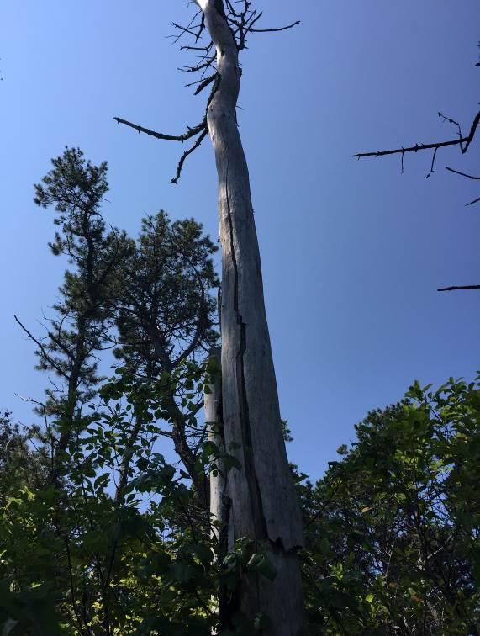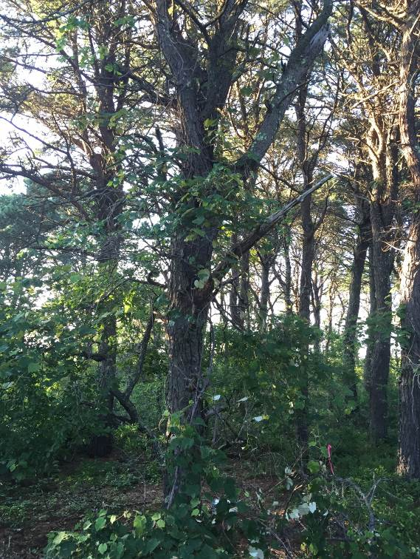

**Figure 1** Roost trees used by F259 on a) July 21 and b) July 22. Both trees were pitch pine. (Photos by Danielle O’Dell)

1. **b)**

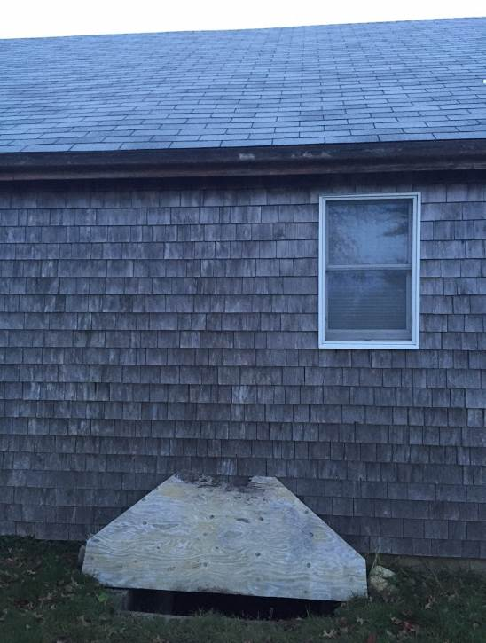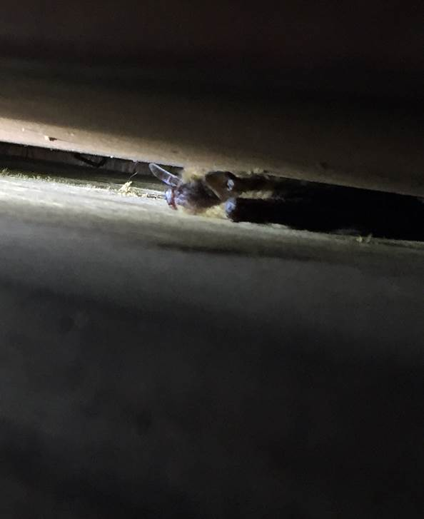

**Figure 2** Roost, and potential hibernation site, used by M269 and at least four other northern long-eared bats, a) the hole into the crawl space, and b) one of the bats roosting between sistered floor joists. (Photos by Danielle O’Dell)